145. Binary Tree Postorder Traversal
Easy

Given the root of a binary tree, return the postorder traversal of its nodes' values.

Example 1:
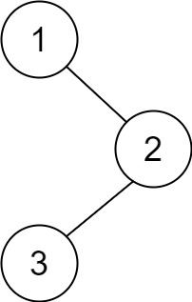
Input: root = [1,null,2,3]
Output: [3,2,1]
Example 2:
Input: root = []
Output: []
Example 3:
Input: root = [1]
Output: [1]

Constraints:
- The number of the nodes in the tree is in the range [0, 100].
- -100 <= Node.val <= 100

